**MESD LMS Documentation - Grade student assignments/quizzes**

**Purpose**

To allow educators to grade student assignments and quizzes.

**Usage**

1. Log in as an **Educator.**
2. Navigate to a course.
3. Click on a quiz/ assignment
4. For quizzes:

Quizzes are normally automatically graded based on a marking scheme that you will create when making the quiz but you can manually grade as well e.g for essay questions which can’t be auto-graded.

To Manually Grade a Quiz Question:

* 1. Click on the quiz with questions that need to be manually graded.
  2. On the quiz page, click on the link to *Attempts* and scroll down to the list of students. This list can be filtered by several data points such as enrollment status, attempt status, and grading status.



* 1. There are a few options for finding the question you need to grade. Clicking on either *Review attempt* or *Not yet graded* will take you to the top of the quiz page. To go directly to the question that needs grading, click *Requires grading* in the question column.

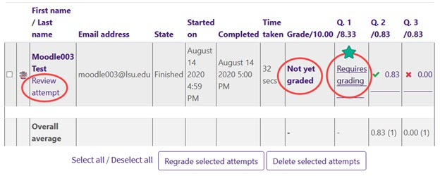

* 1. When you click on "Requires grading," a pop-up will appear that contains data for that individual response. To enter a grade and leave feedback, click "Make comments or override points."

* 1. A new pop-up window will open where you can type in the Comment box and enter a grade. If you have entered information for graders in the quiz settings, this will display above the comment box.

* 1. Scroll down in the pop-up to save your response and the grade.

To Access Only Manually Graded Quiz Questions:

* Click on **Results** for the quiz.
* Click the drop-down menu right under the Results tab.
* Click **Manual grading.**

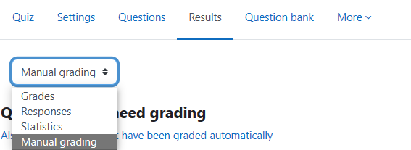

1. For Assignments:
   1. Click on an assignment.
   2. Click **Grade** to jump into grading learners directly.

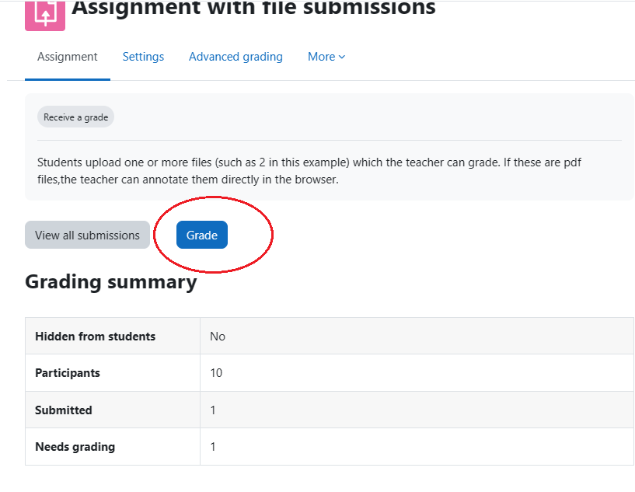

* 1. Click **View all submissions** to view individual submissions. You can also click **Grade** to grade that specific individual.

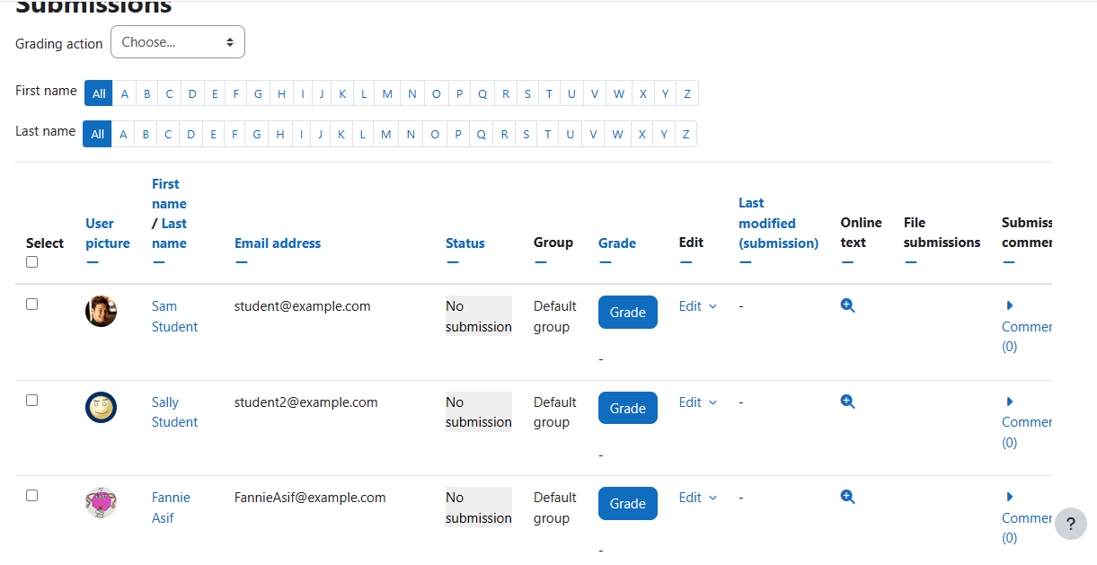

* 1. Grade a student’s work. This is an example of a page that you should see.